**fast.ai Confusion Matrices and Analysis**

Built-in MNIST Dataset:

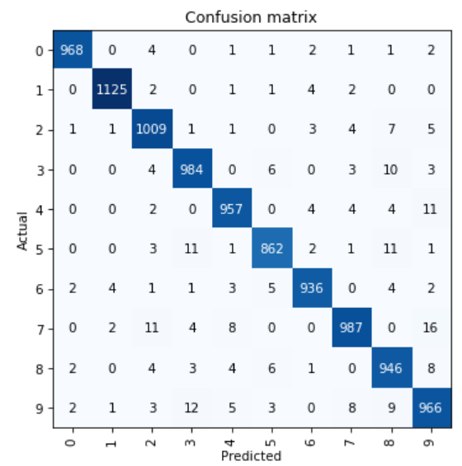

Self-Made Smiles VS Frowns Dataset:

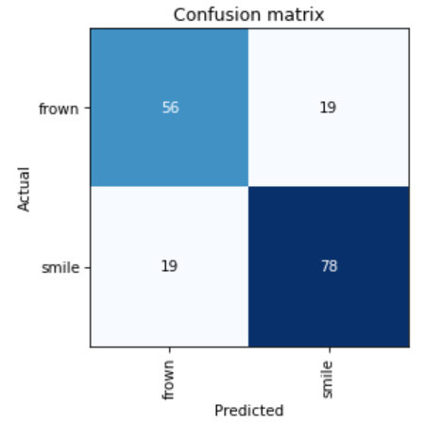

Analysis:

The fast.ai resnet34 model surprised me with its versatility. It performed more accurately on MNIST than my hand-coded perceptrons network. Whereas my model reached an approximate 5% error rate after 5 epochs of training, the resnet34 model had about a 2.5% error rate after the same number of epochs, roughly halving the error rate. According to the confusion matrix, it particularly struggled with mistaking “7’s” for “9’s” (16 errors) and “9’s” for “3’s” ( 12 errors). These errors are not unexpected given the similarities between those digits when handwritten.

The resnet34 model also performed fairly well on my (very poorly curated) dataset of face images even though the new task was strikingly different from that of MNIST. Again after 5 epochs of training, it was able to distinguish between smiling and frowning faces with about 75% accuracy overall. The confusion matrix suggests that it was better at identifying smiles than frowns, with a 20% error rate for smiles as opposed to a 25% error rate for frowns. Compared to that for MNIST, the error rate is rather high, but I attribute this to my own poor image selection rather than intrinsic flaws in the resnet34 model.

Dataset issues were actually a running “theme” of sorts in this assignment. The most time-consuming and frustrating part of the tasks had very little to do with AI. Rather, I struggled most with simply getting the MNIST dataset to properly work with my code. Actually training the resnet34 model and outputting results was far simpler than traversing the fast.ai documentation and forums. I encountered new challenges in building my own image dataset from Google Images. Some of my favorite ideas, which included sorting our solar system’s planets, had to be scrapped because the images I found were overwhelmingly irrelevant, watermarked, and/or mislabeled. I have gained a new appreciation for those who work to build and maintain AI datasets. Just as the lesson 1 video states, they are truly underrated.

For all of my dataset woes, fast.ai is amazing! As in, it is the coolest assignment we have done all year. I am shocked that a computer can actually identify handwritten numbers and faces with fairly high accuracy--sometimes even humans struggle with those tasks.